Lecture 3-4 Worksheet Name:

**1. Parameter Mystery**  
At the bottom of the page, write the output produced by the following program.

public class ParameterMystery {

public static void main(String[] args) {

String x = "java";

String y = "tyler";

String z = "tv";

String rugby = "hamburger";

String java = "donnie";

hamburger(x, y, z);

hamburger(z, x, y);

hamburger("rugby", z, java);

hamburger(y, rugby, "x");

hamburger(y, y, "java");

}

public static void hamburger(String y, String z, String x) {

System.out.println(z + " and " + x + " like " + y);

}

}

**2. Parameter Mystery 2**  
At the bottom of the page, write the output produced by the following program.

public class ParameterMystery {

public static void main(String[] args) {

String x = "happy";

String y = "pumpkin";

String z = "orange";

String pumpkin = "sleepy";

String orange = "vampire";

orange(y, x, z);

orange(x, z, y);

orange(pumpkin, z, "y");

z = "green";

orange("x", "pumpkin", z);

orange(y, z, orange);

}

public static void orange(String z, String y, String x) {  
 System.out.println(y + " and " + z + " were " + x);

}

}

**3. If/Else Simulation**  
For each call of the method below, write the value that is returned:

public static int mystery(int a, int b) {

int c;

if (a > b) {

c = a;

} else if (b % a == 0) {

c = b;

} else {

c = b + (a - (b % a));

}

return c;

}

Method Call Value Returned

mystery(4, 2) ___________________

mystery(5, 4) ___________________

mystery(5, 13) ___________________

mystery(5, 17) __________________

mystery(4, 8) ____________________

**4. If/Else Simulation 2**For each call of the method below, write the value that is returned:

public static int mystery(int n) {

if (n < 0) {

n = n * 3;

return n;

} else {

n = n + 3;

}

if (n % 2 == 1) {

n = n + n % 10;

}

return n;

}

Method Call Value Returned

mystery(-5) ___________________

mystery(0) ___________________

mystery(7) ___________________

mystery(18) ___________________

mystery(49) ___________________

**5)**

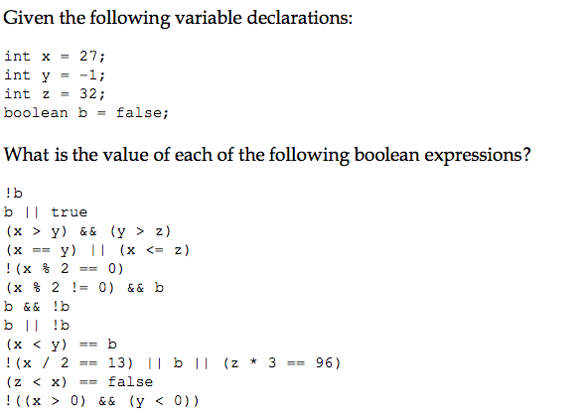

**6)** Rewrite the following without using the ! operator.

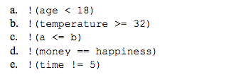

**7)**

